Case 6-Asia-China-Zhou-Gui Tureen-Bronze-1000 BCE

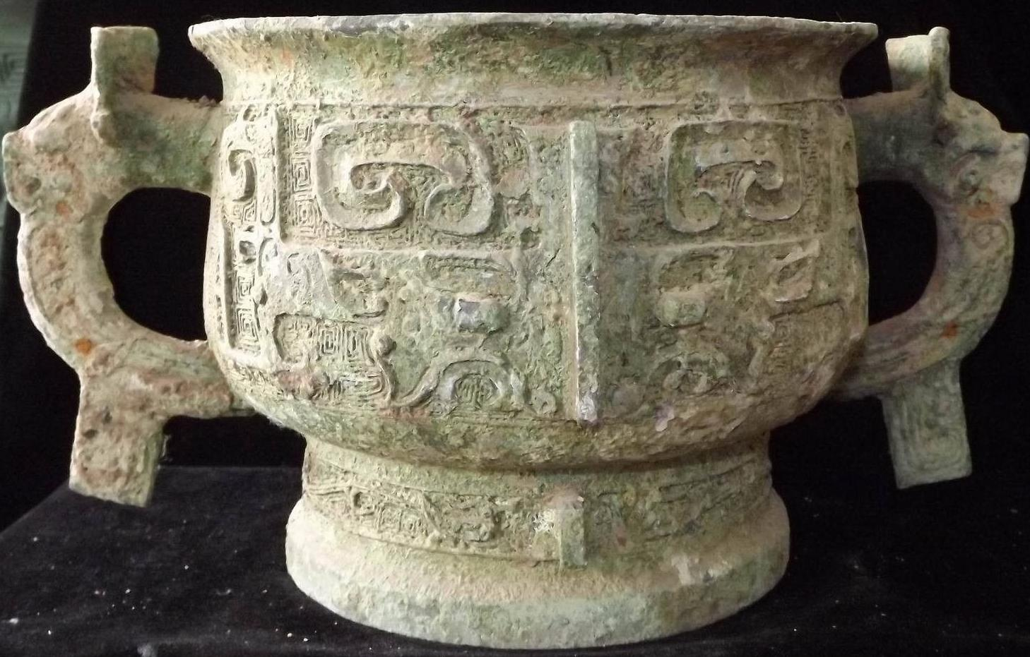

Case No.: 5

Accession Number:

Formal Label:

**Display Description:**

Edward L. Shaughnessy has identified four different Western Zhou Gui styles of which he has called this Style I or the Li Gui style, the earliest of which is characterized as the most heterogeneous with a “pronounced relief décor of facing animal heads and by flamboyant handles and flanges” (Shaughnessy 1992: 129 and fig. 2a).

LC Classification: NK7983.

Date or Time Horizon: 1000 BCE

Geographical Area: Zhou Kingdom

Map:



GPS Coordinates:

Cultural Affiliation: Zhou

Medium: Bronze

**Dimensions**:   
**Weight:**

**Provenance**:

**Condition:**

**Discussion:**

A comparable example is in the Avery Brundage Collection ( d'Argencé 1967:34-35, no. IX).

**References:**

d'Argencé, René-Yvon Lefebvre. 1967. Bronze vessels of ancient China in the Avery Brundage Collection. San Francisco: Asian Art Museum of San Francisco. [Berkeley, Calif.]: Published by Diablo Press for the De Young Museum Society

Shaughnessy, E.L., 1992. *Sources of Western Zhou history: inscribed bronze vessels*. Los Angeles: University of California Press.

Appendix:

